Fundamentals of Data Science – Simple Python Programs
Name : AGATHAMUDI VARSHINI
Reg No : 1924260356
Code : DSA0409
Slot : A

Question 1: Student Subject Averages using NumPy
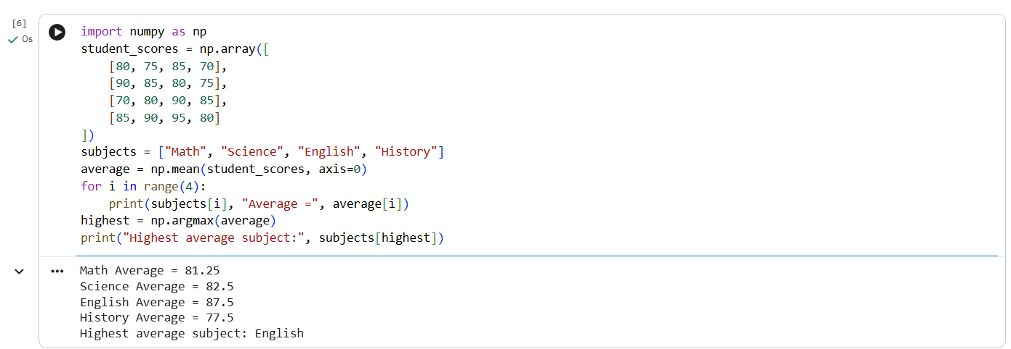

Question 2: Average Product Price using NumPy
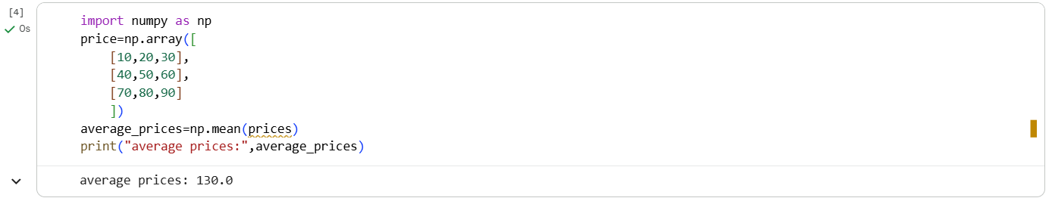

Question 3: Average Sale Price of Houses with More Than 4 Bedrooms
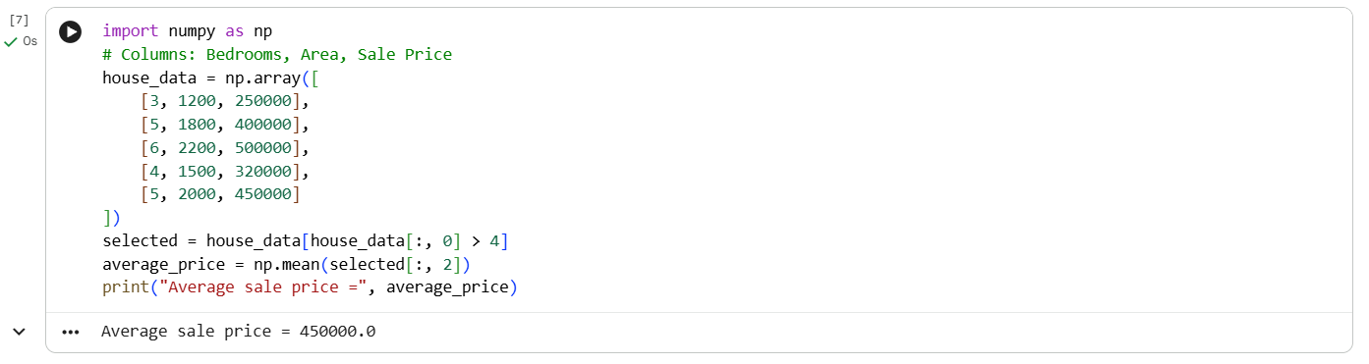

Question 4: Total Yearly Sales and Percentage Increase
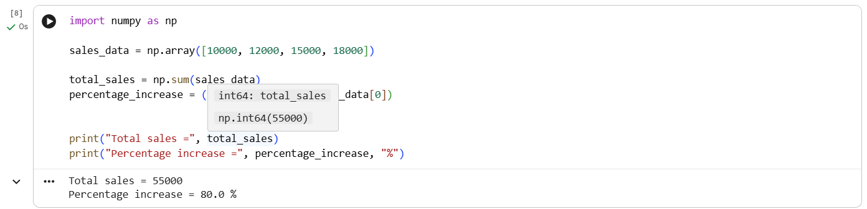

Question 5: Average Fuel Efficiency and Percentage Improvement
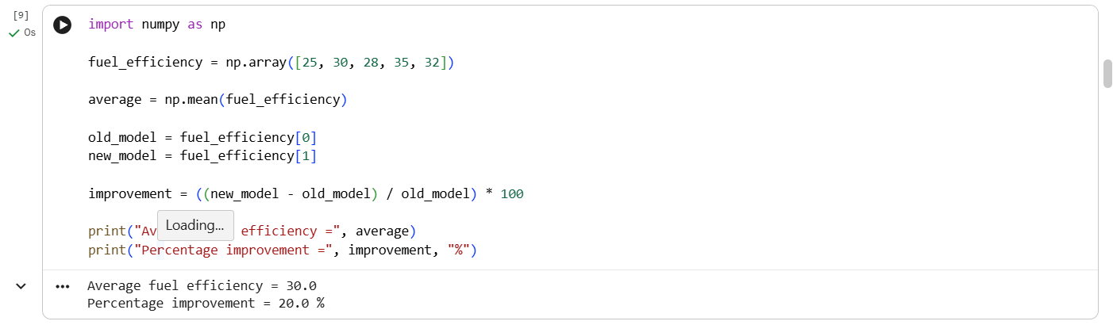

Question 6: Total Grocery Cost with Discount and Tax
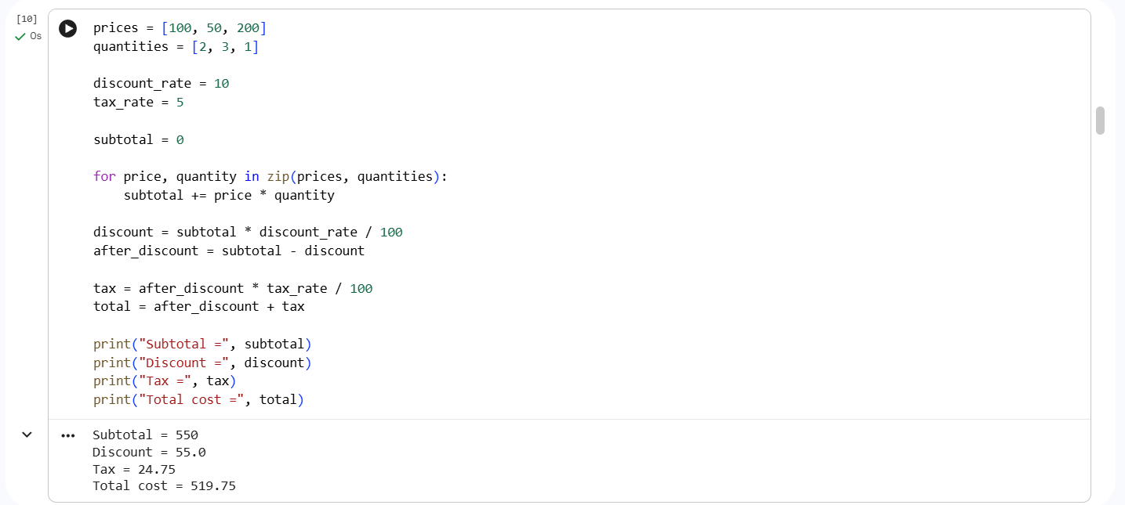

Question 7: Pandas Order Analysis
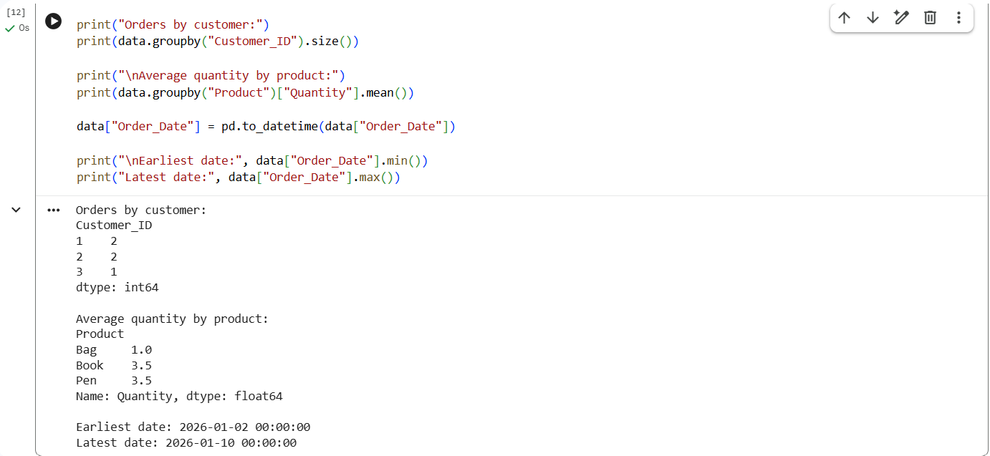

Question 8: Top 5 Products Sold
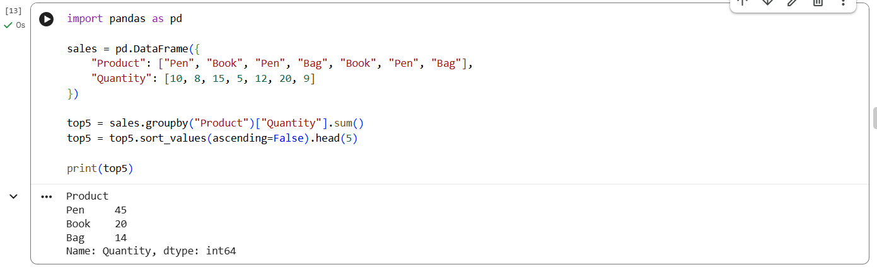

Question 9: Property Data Analysis using Pandas

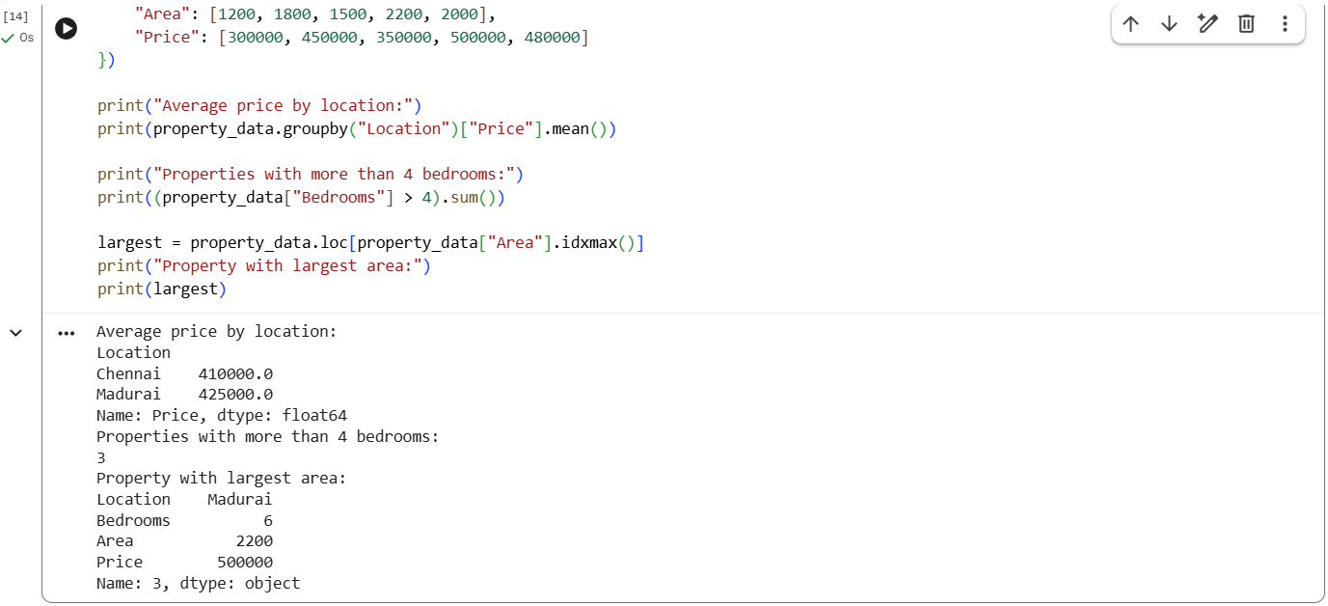

Question 10: Monthly Sales – Line Plot and Bar Plot

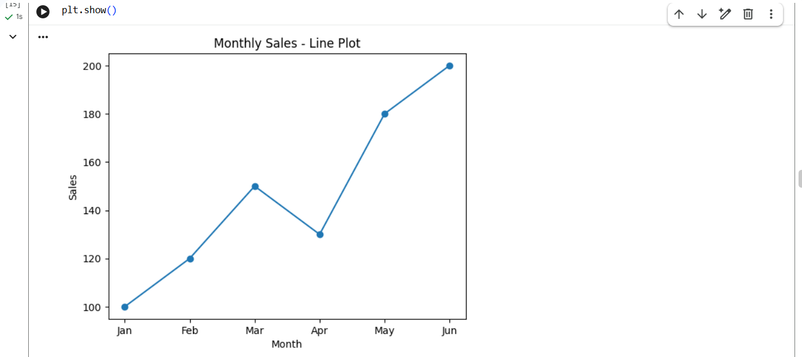
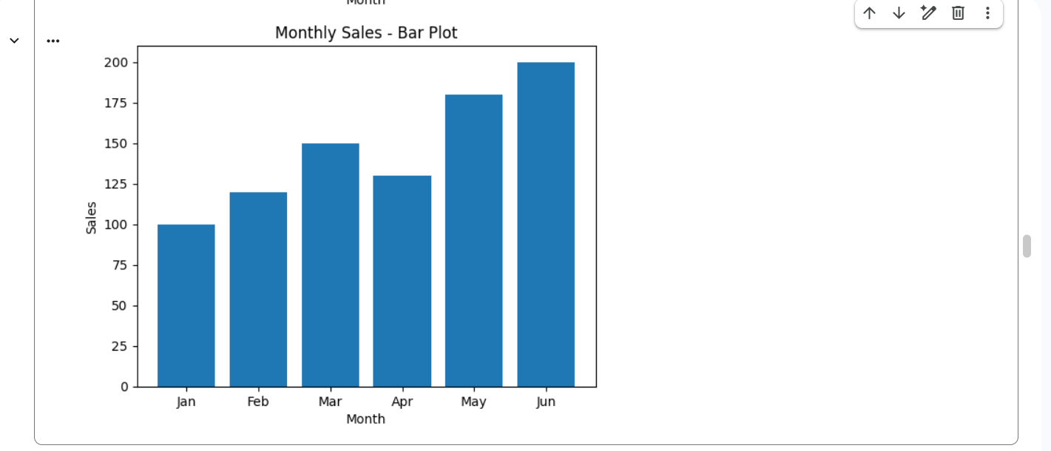

Question 11: Sales over Time – Line, Scatter and Bar Plots

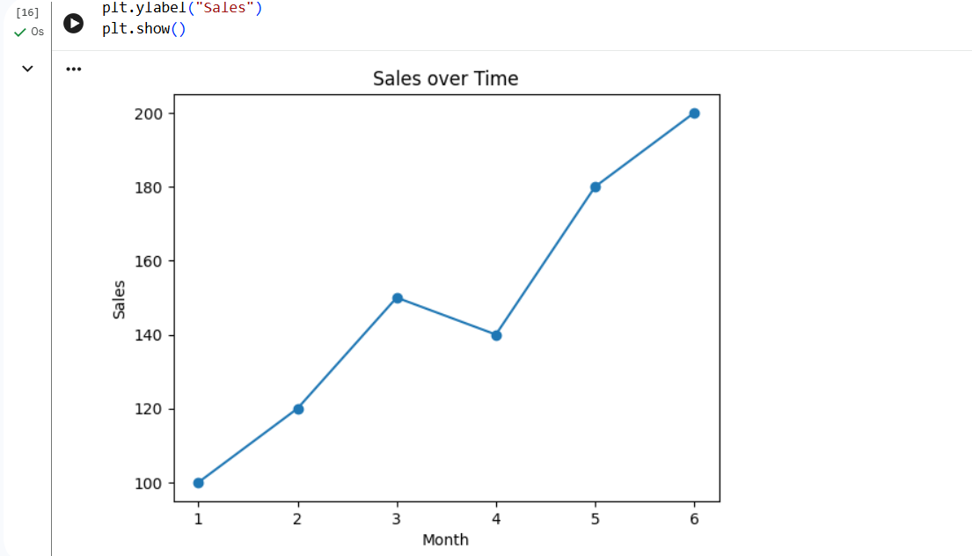
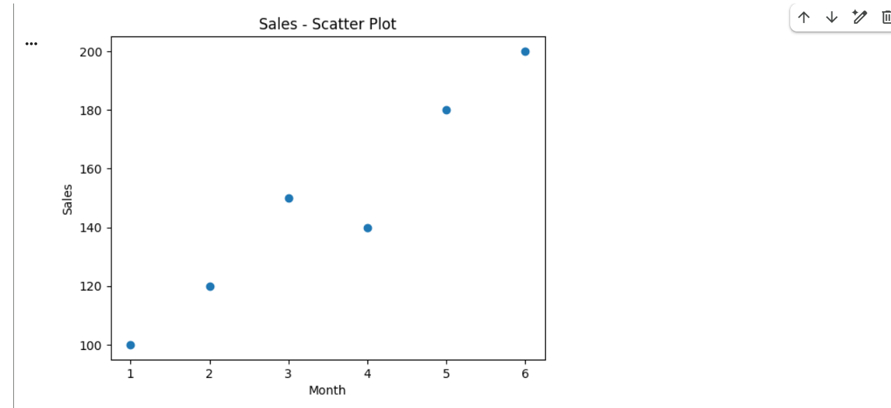
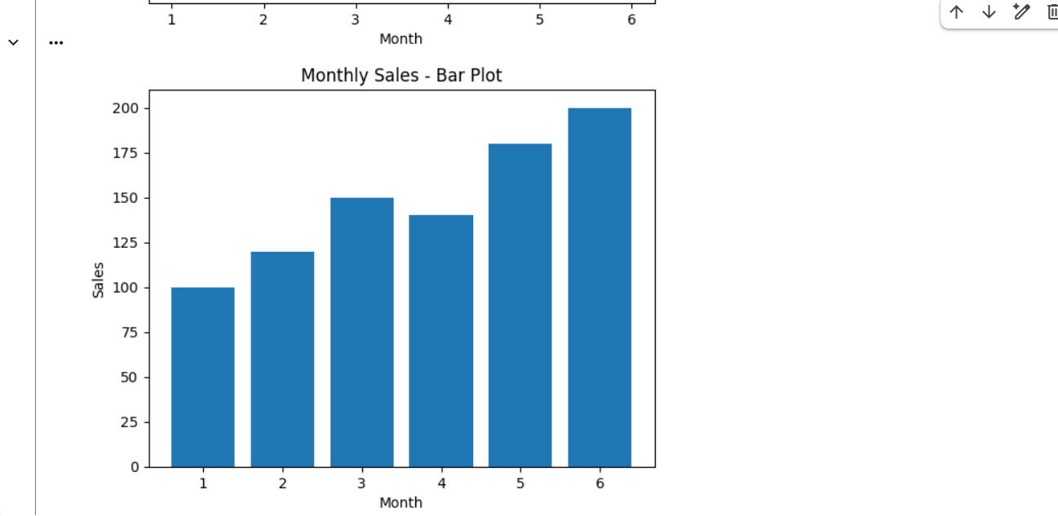

Question 12: Monthly Temperature and Rainfall Plots
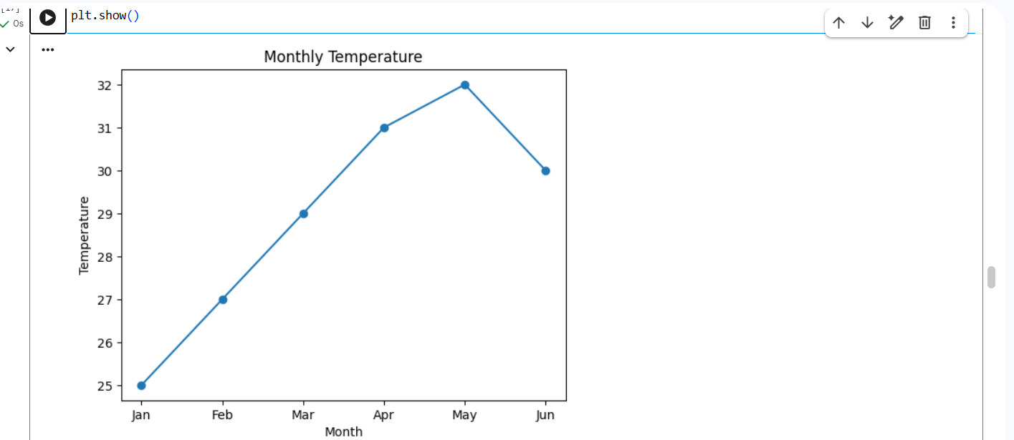
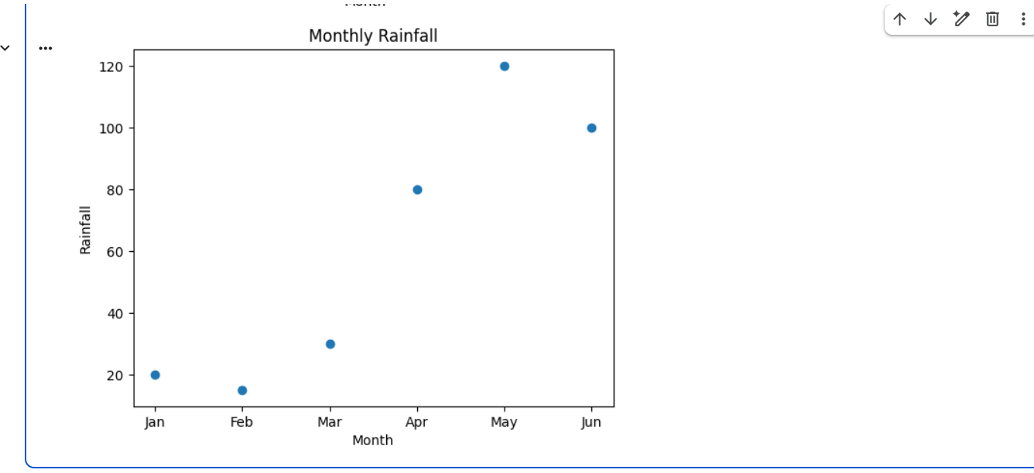

Question 13: Word Frequency from a Text File
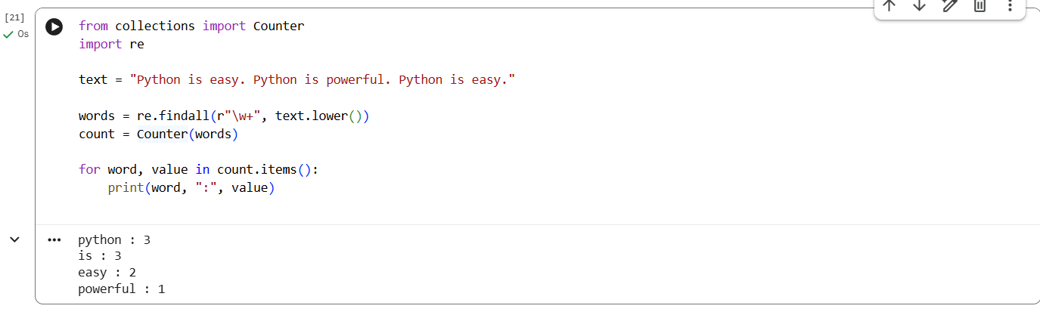
Question 14: Frequency Distribution of Customer Ages
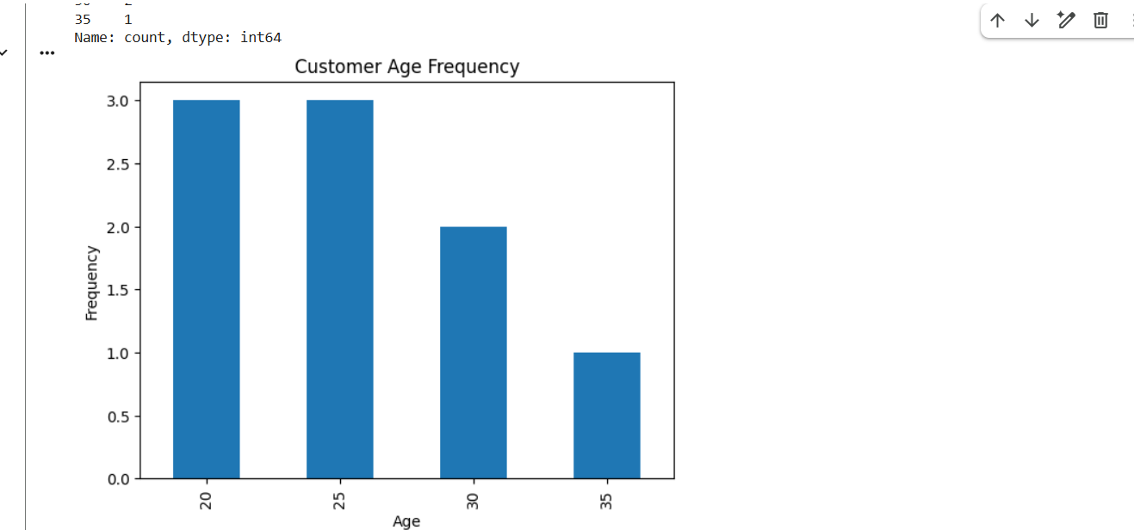

Question 15: Frequency Distribution of Likes
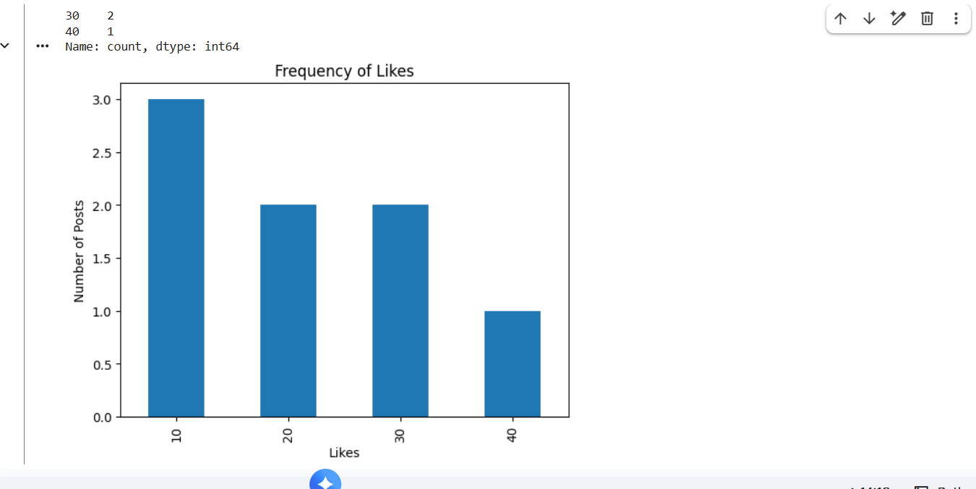

Question 16: Word Frequency in Customer Reviews
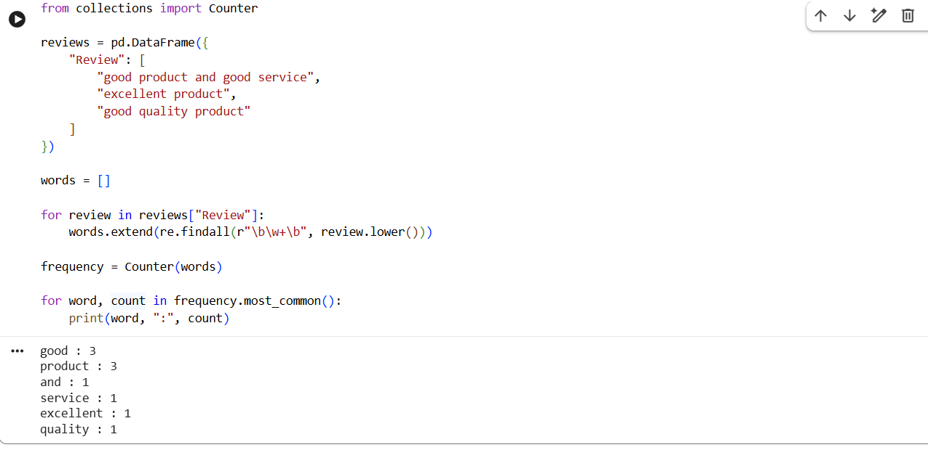

Question 17: Customer Feedback – Top N Word Frequency
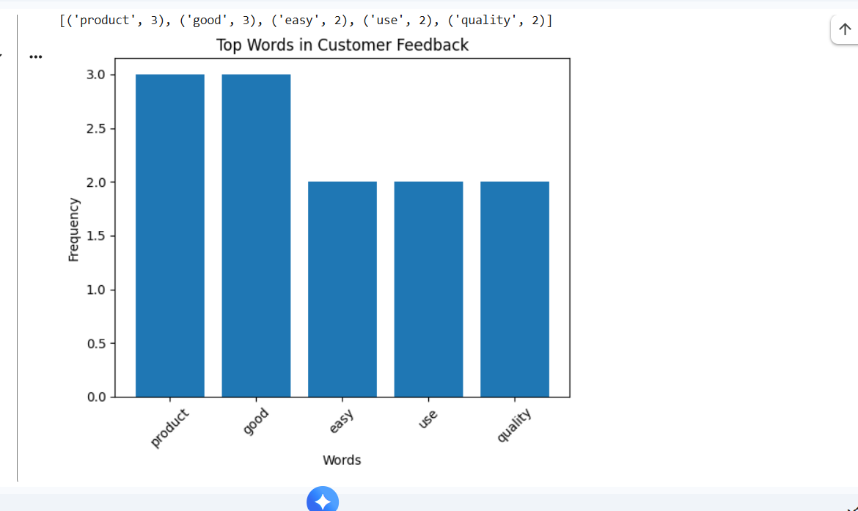

Question 18: Mean, Median, Standard Deviation, Boxplot, Scatter Plot and Q-Q Plot
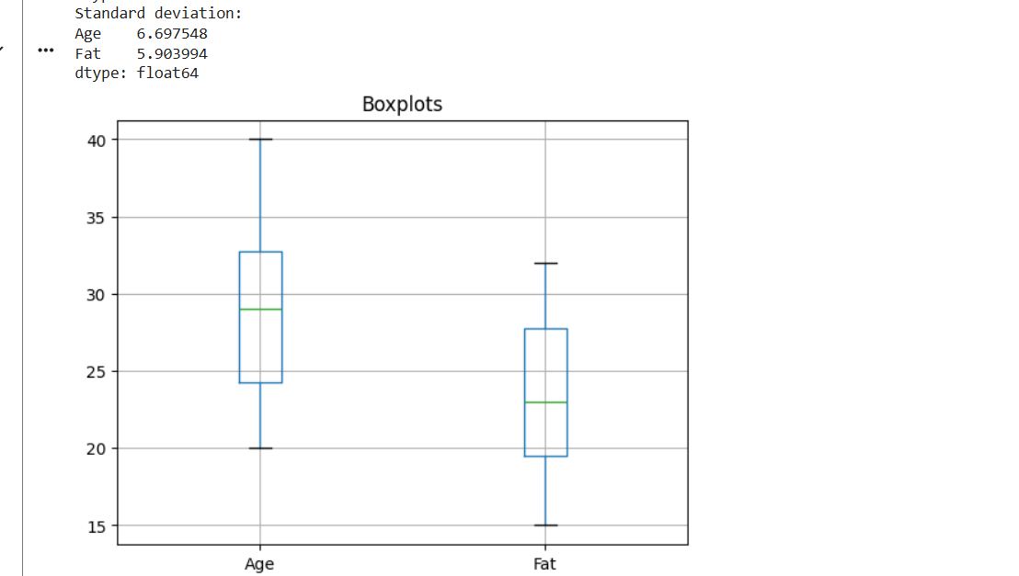
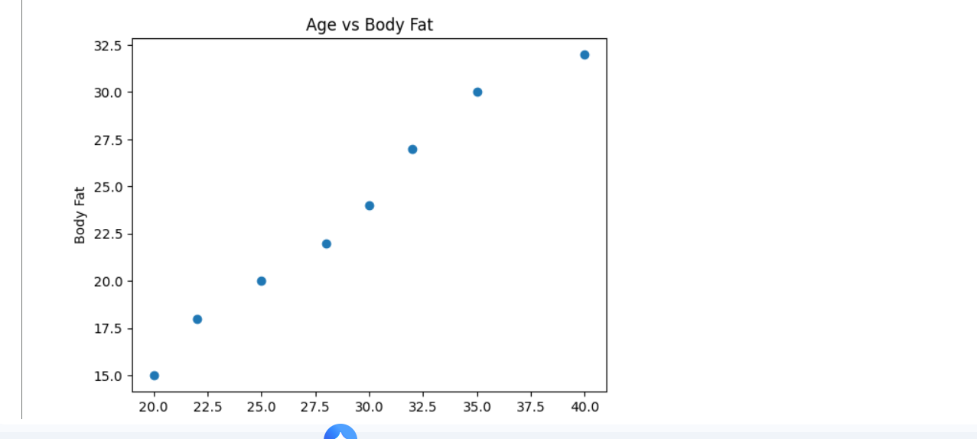

Question 19: 95% Confidence Interval for Blood Pressure Reduction
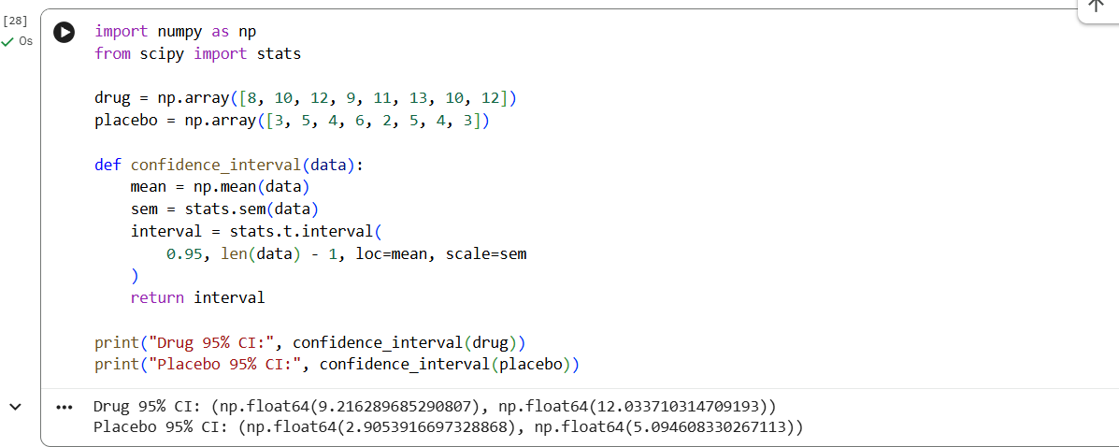

Question 20: A/B Test – Compare Two Conversion Rate Samples
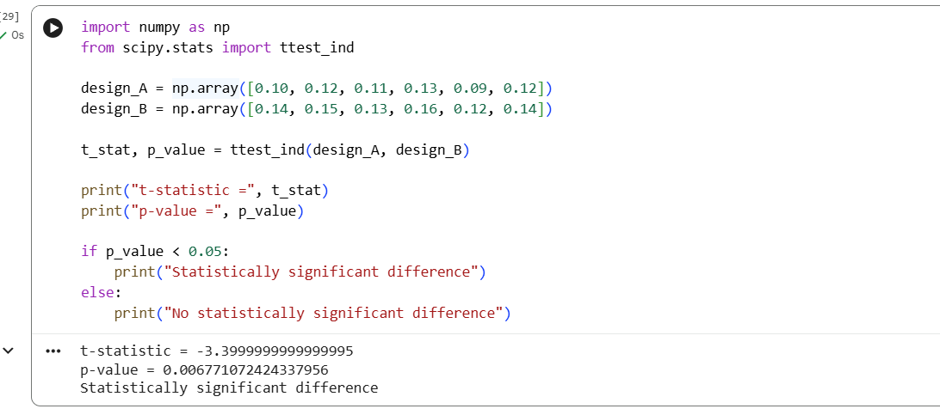

Question 21: Point Estimate and Confidence Interval from CSV
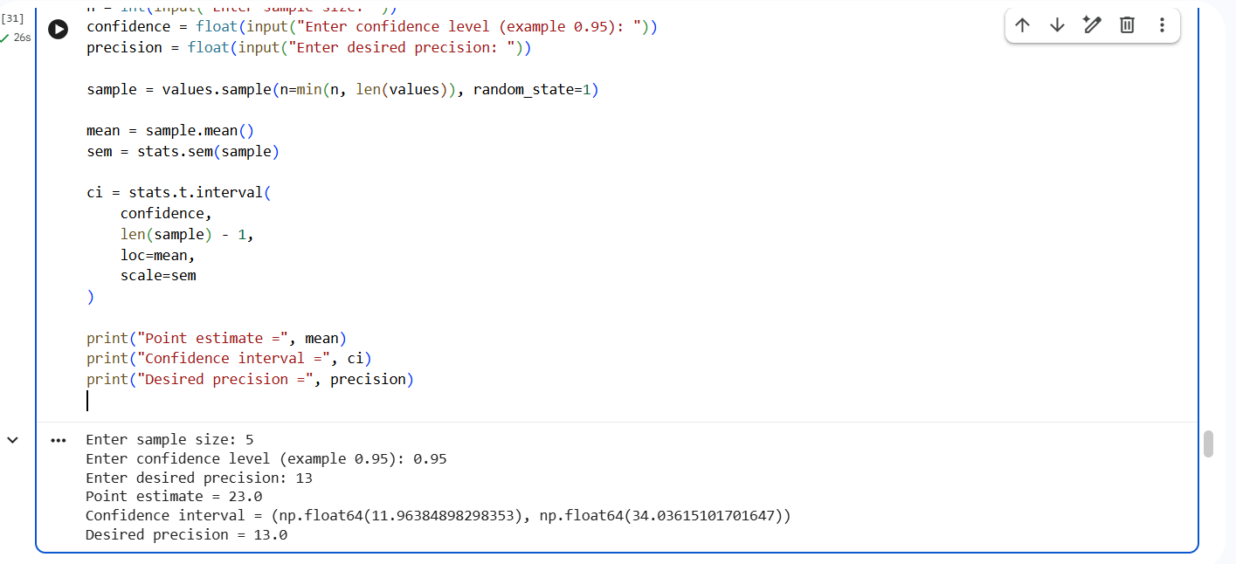

Question 22: Confidence Interval for Mean Customer Rating
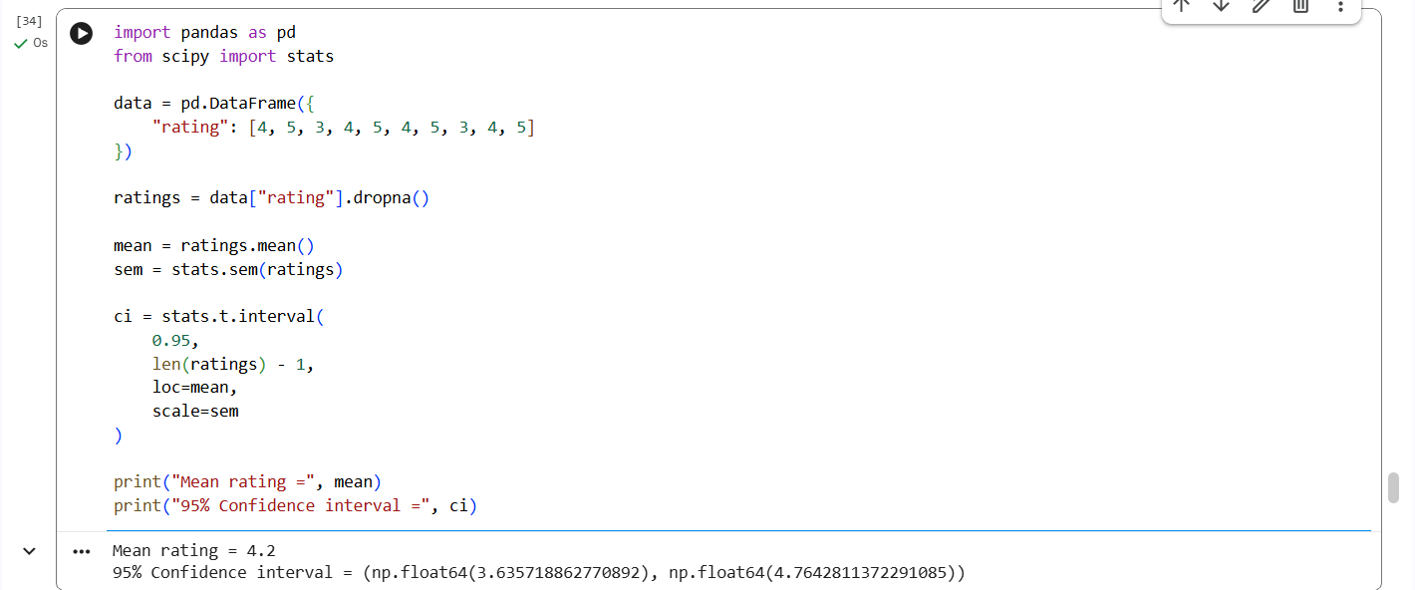

Question 23: Hypothesis Testing for Treatment vs Placebo
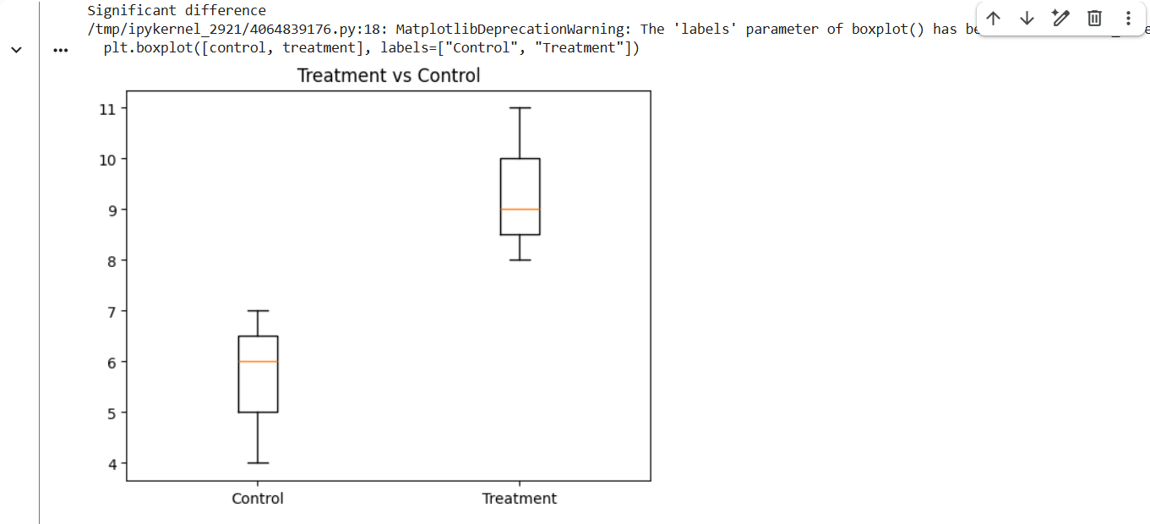

Question 24: KNN Classifier for a New Patient
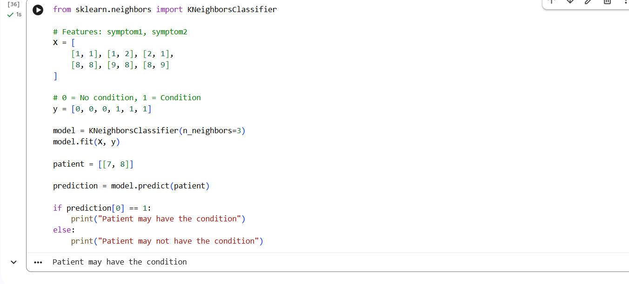

Question 25: Decision Tree for Iris Classification
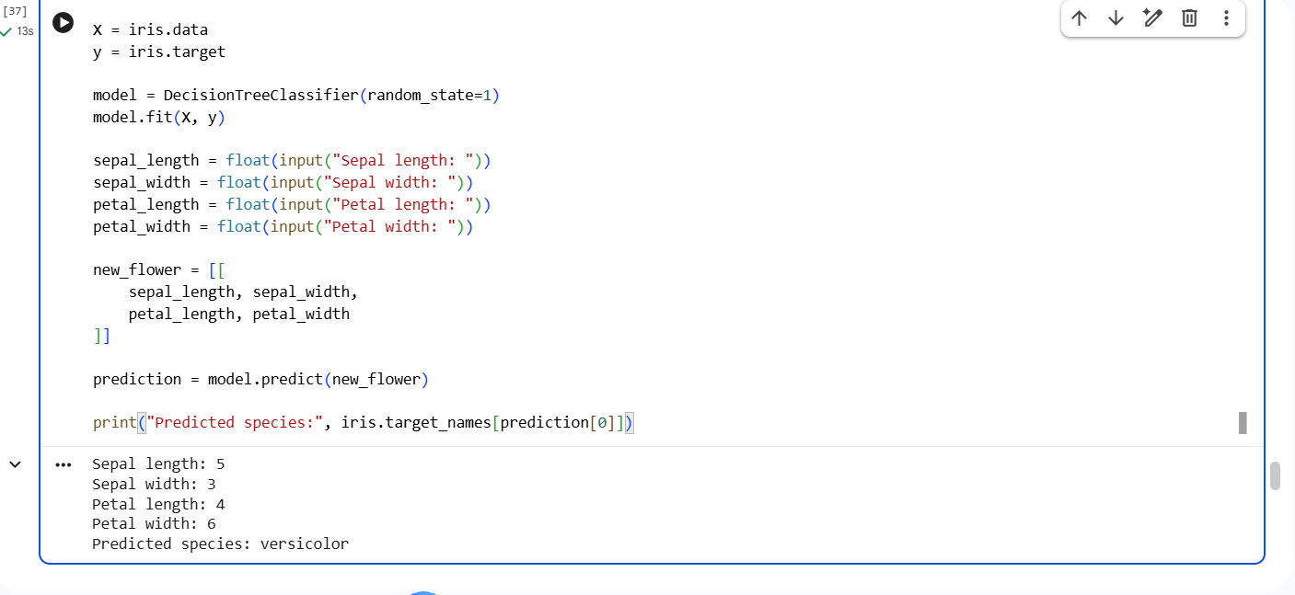

Question 26: Linear Regression for Housing Price Prediction
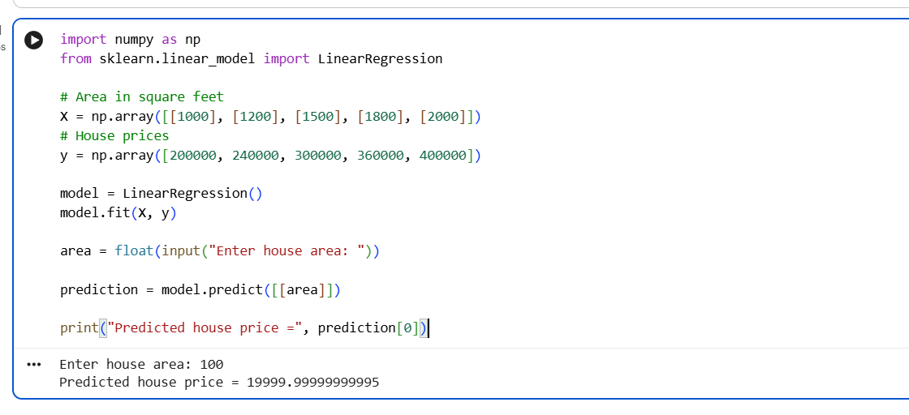

Question 27: Logistic Regression for Customer Churn
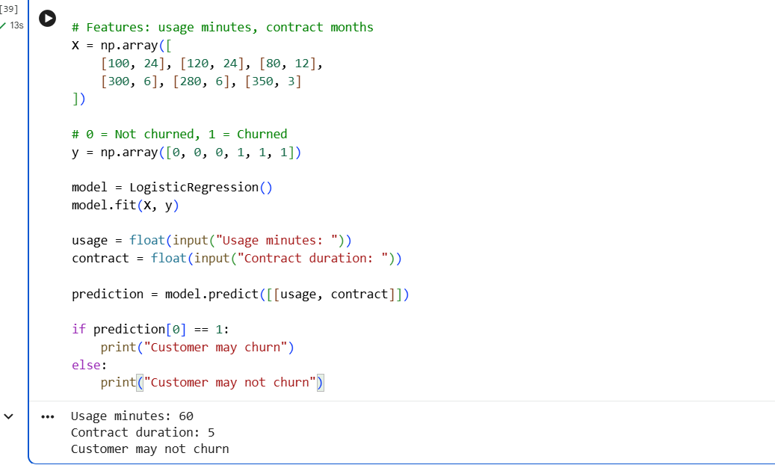

Question 28: K-Means Customer Segmentation
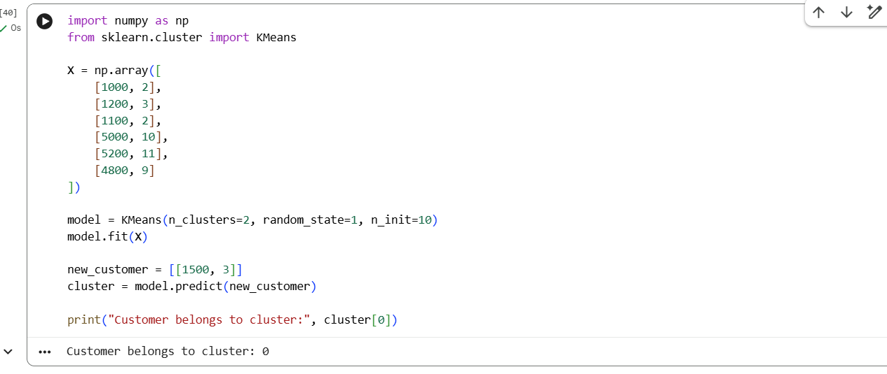

Question 29: Accuracy, Precision, Recall and F1-Score
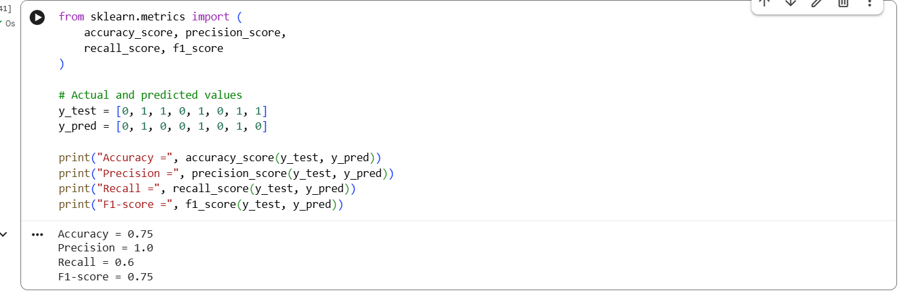

Question 30: CART Regression for Used Car Price
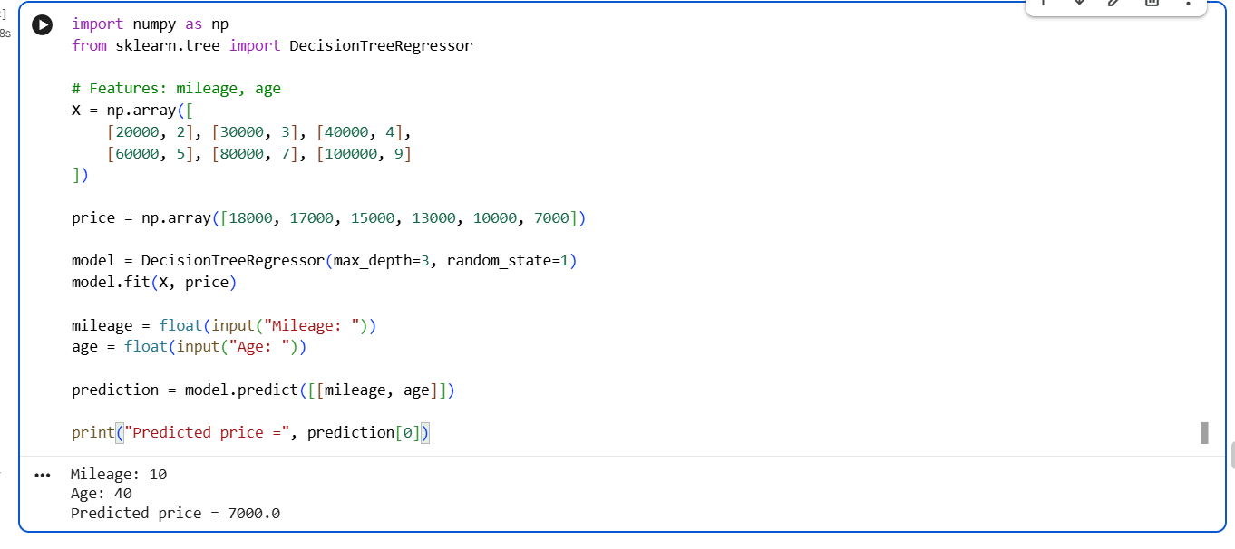

Question 31: Customer Segmentation using K-Means
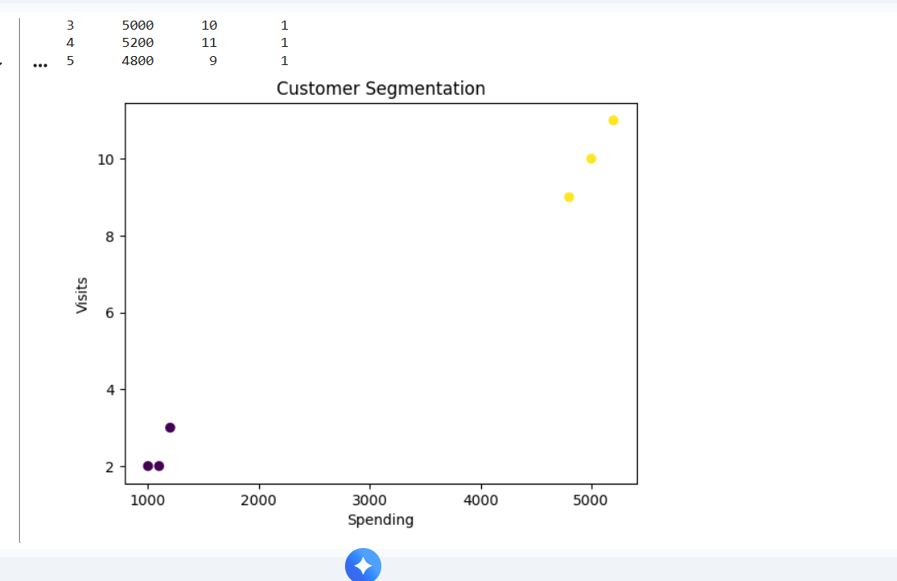

Question 32: Bivariate Analysis and Linear Regression for House Price
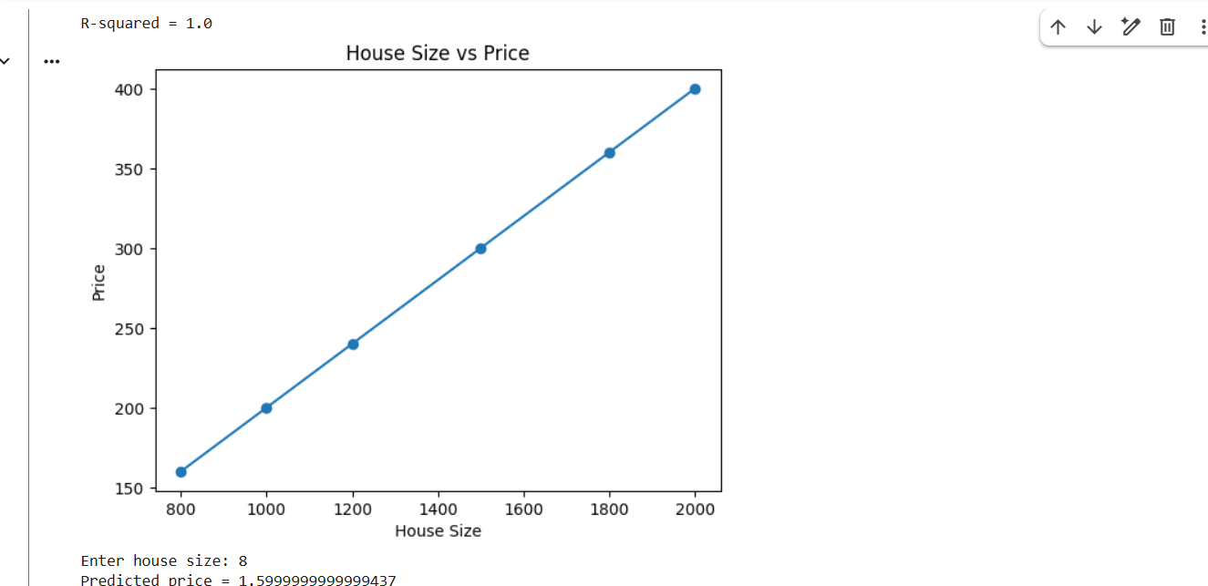

Question 33: Multiple Linear Regression for Car Price
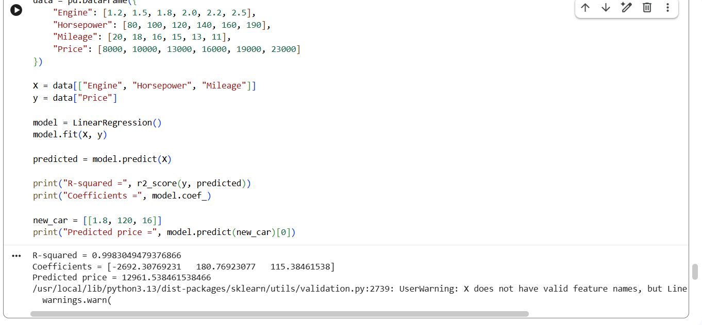

Question 34: KNN Classification with Evaluation Metrics
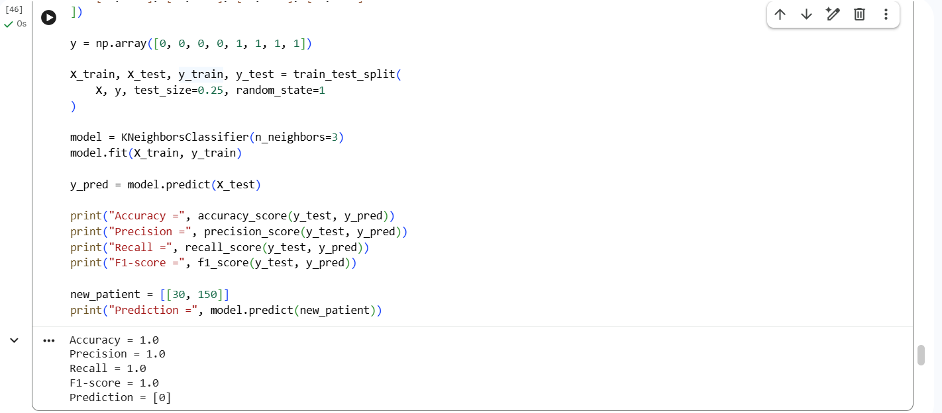

Question 35: K-Means Clustering for Retail Customers
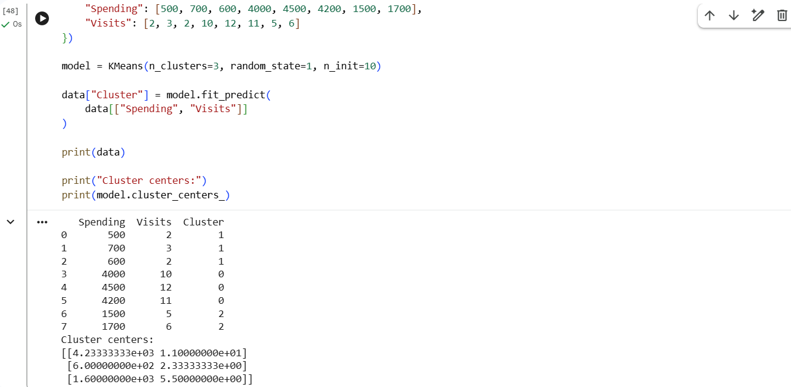

Question 36: Stock Price Variability from CSV
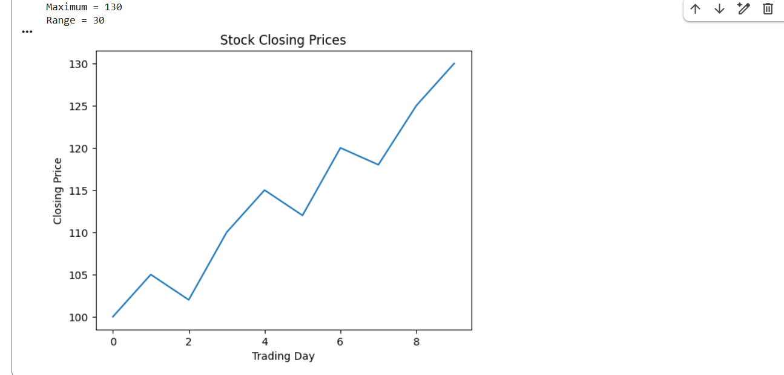

Question 37: Correlation between Study Time and Exam Score
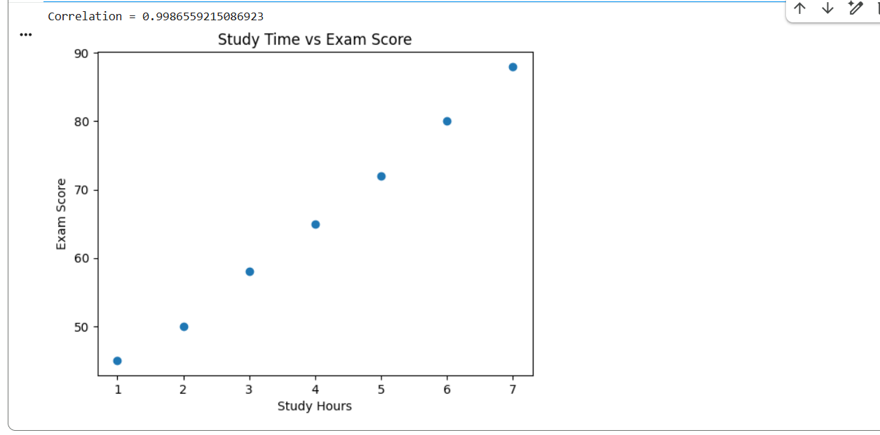

Question 38: Temperature Analysis for Different Cities
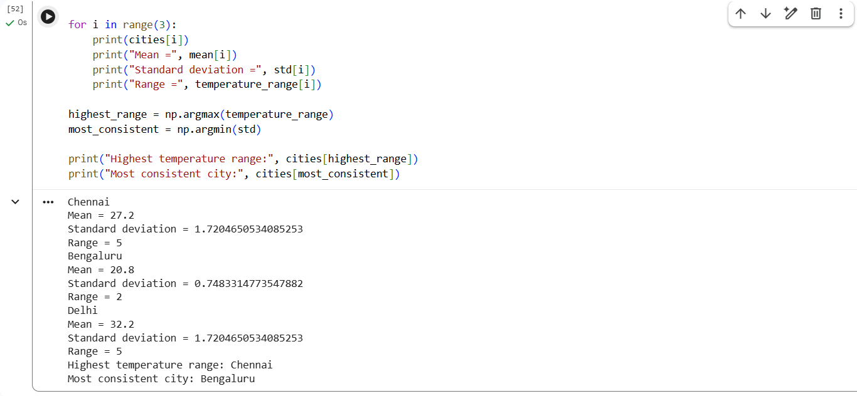

Question 39: K-Means Clustering and Visualization
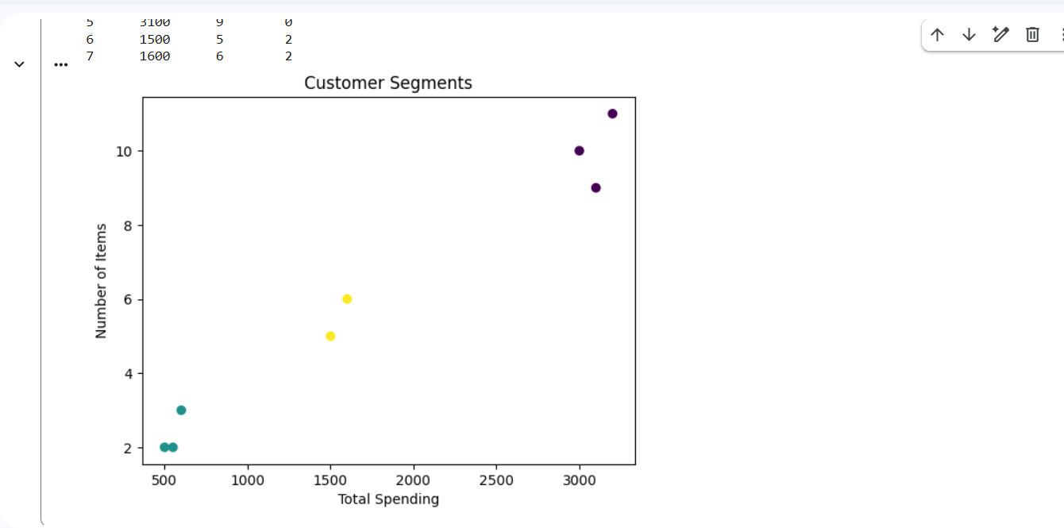

Question 40: Soccer Player Analysis using Pandas
